Trapping Moths
Moth traps are straightforward to build - basically a square wooden box with an open top into which two pieces of Perspex are placed in a "V" shape with a gap at the bottom of the V. A mercury vapour lamp is placed on top of all this, the moths are attracted, they fall down the slippery Perspex sides and end up in the trap where egg boxes have been placed for them to nestle in. This is called a Skinner moth trap. Set the trap up before dusk, switch the lamp on and go to bed. In the morning you should find dozens and dozens of moths hiding under the egg boxes in the trap. They will all be fairly sleepy, so don't be too concerned about them flying off before you have a chance to look at them. A digital camera with good macro facilities is an excellent investment to record your catches.
The moths are not harmed by trapping, but when you release them from the trap make sure you scatter them across a largish area of long vegetation as otherwise you're setting up lunch for all your garden birds.

How Can I Build A Moth Trap?
This design for a moth trap is borrowed from the BBC web site. It's since been deleted from there, so I reckoned no-one would mind me propagating it here as it's a very generic design. The finished moth trap is shown opposite.

What You Need
- One sheet of 4 mm plywood cut into:
  - one 40 cm square - base,
  - two 30 cm x 40 cm - ends,
  - two 30 cm x 39 cm - sides,
  - one 7 cm x 39 cm - support for light.
- One sheet of 2 mm Perspex cut into:
  - two 30 cm x 39 cm,
  - one 30 cm x 30 cm for rain cover if desired.
- 2 cm square baton cut into:
  - two 35 cm lengths - at bottom of ends,
  - two 39 cm lengths - at bottom of sides,
  - four 25 cm lengths - along edges,
  - four 6.5 cm lengths - two for Perspex support, two for light.
- Two egg trays or 6 to 8 half-dozen sized egg boxes.

External light fitting, mercury vapour lamp, insulated electrical cable, plug - all of these electrics can be purchased in kits from www.pwbelg.clara.net/mercury.

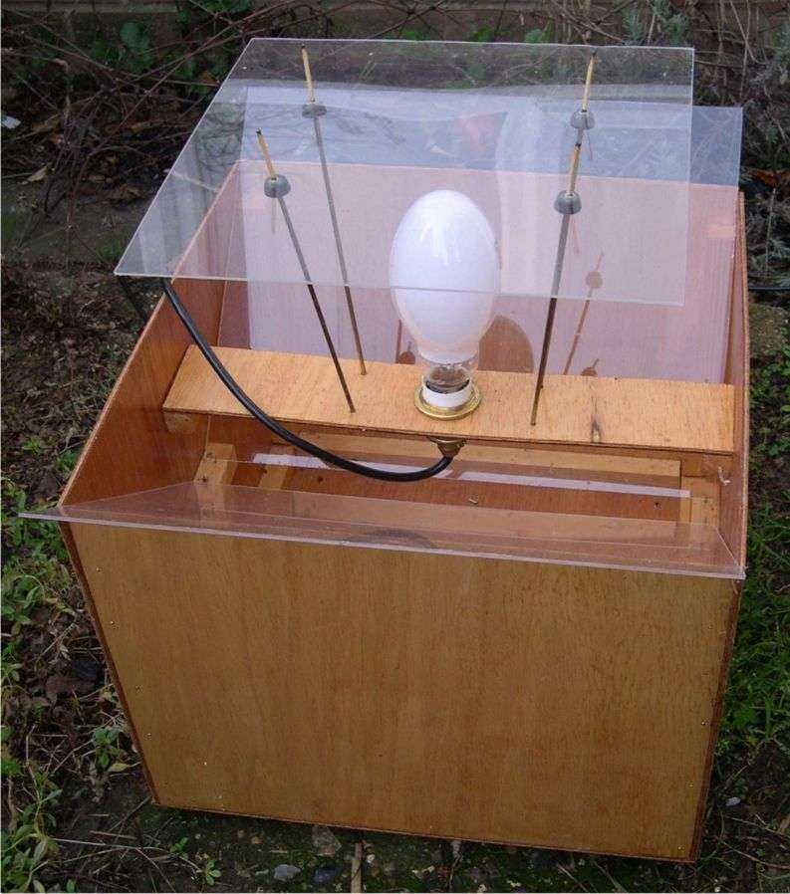

What To Do
Assemble the main box. The trap is held together by the 2cm baton that runs around inside. The plywood pieces can be glued or nailed to the baton to join them together. Drill some small holes in the corners of the base to let any rainwater out. Nail two nails, 2.5 cm apart into two of the 6.5 cm lengths of baton. These will form the rests for the Perspex. Glue the rests onto the two ends of the box, 15 cm above the base in the centre. Prop up the egg boxes inside your trap and slide the two Perspex sheets in so they are stopped by the nails.
Assemble the lighting. Wire up the external light to the plug following the manufacturer's instructions. Drill a hole in the centre of the plywood support to take the external light fitting and screw it into place. Glue the other two 6.5 cm piece of baton above the Perspex rests, 6 cm down from the top, these will form the support for the lighting. Glue this plywood lighting unit on top of the supports and varnish the lot (for outdoor use). You are now ready to trap.
The only thing missing from this basic design is a rain cover. If you're afraid it's going to rain on your very expensive mercury vapour lamp, then take the extra piece of Perspex plus some long straight pieces of thick wire (I used some thin brass tubing I happened to have spare) and make a cover (which should be removable). Put the trap on the ground or just a foot or two above; very few moths fly much higher than this. If you put it against a hedge or the edge of a wooded area it will probably stand the best chance of success.

